**June 24, 2024**

# ****Weather:****

**U.S. MIDWEST**

·            ***Rain fell on much of the Midwest outside of some southwestern locations during the weekend and temporary relief from dryness occurred in the driest areas form north-central and eastern Missouri to Ohio and Kentucky where much of the rain was light and the moisture will be quickly lost to evaporation.***

* Rain was greatest from eastern South Dakota to southern Minnesota and northern Iowa to central and southern Wisconsin and north-central and northeastern Illinois to western Michigan and north-central Indiana.
* Heavy rain and some flooding occurred from southeastern South Dakota to south-central and east-central Wisconsin where totals were 1.42 to 4.16 inches.
* Rainfall totals elsewhere across the Midwest were up to 0.73 inch most often with several totals of 1.0 to 1.13 inches and a total of 2.73 inches in a part of interior east-central Nebraska while parts of southeastern Nebraska, eastern Kansas, and central Missouri along with a few other pockets were left dry.
* Highest temperatures from eastern Nebraska and eastern Kansas to Ohio, Kentucky, and southern Michigan were in the lower to middle 90s Fahrenheit with a few upper 80s in the north and a few upper 90s in the south.

**Forecast Overview and Crop Impacts**

·         ***Hot and dry weather today from the southwestern to the eastern Corn Belt will stress crops, and especially crops in the many areas with short topsoil moisture, before a wetter and cooler weather pattern occurs Tuesday into Wednesday, July 3.***

o   ***Enough rain is expected to induce at least temporary improvements in soil topsoil moisture while improving conditions for crops and especially newly-planted crops with shallow root systems in need of greater topsoil moisture to become well-established.***

* Today and Tuesday will be the hottest days of the week and crops will be stressed today from southeastern South Dakota to eastern Kansas and western into central where highs reach the upper 90s with some lower 100s.
* Many areas from southeastern Nebraska and eastern Kansas to west-central and southern Indiana and western and central Kentucky will see highs in the middle and upper 90s Tuesday.
* Temperatures during the remainder of the next week will be colder than normal at times in the northwest and will be not far from normal elsewhere with highs reaching the middle 90s on occasion in the lower Midwest.

***The remainder of the western Corn Belt will see little rain into Wednesday and planting should resume in some areas before a couple more rounds of rain occur Thursday through Wed., July 3 slows fieldwork again while keeping the soil moist and maintaining high yield potentials for the many crops that have been planted.***

***A close watch will be made on the July 4-8 period as early indications suggest a warmer and drier weather pattern may evolve.***

* Rain through July 3 should be great enough to prevent much stress from occurring if warmer and drier weather occurs July 4-8, but many areas from the southwestern to the eastern Corn Belt are not likely to receive soaking rain by July 3 and the topsoil may soon run short of moisture again.
* Subsoil moisture should still be supportive of crop development during the second week of July and corn pollination may occur successfully, but greater rain will likely be needed during the second week of the month to ensure the best possible production potentials.

**Precipitation Forecast Details**

* Rain into Wednesday will be greatest from Missouri and southern Iowa to Ohio and western Kentucky where most areas will receive 0.30-1.30” and locally more with a few bands of heavier rain and a few pockets of lighter rain.
* Much of the remainder of the Midwest will receive up to 0.75” and locally more with some pockets of dry weather and the eastern Dakotas to western Minnesota and northwestern Iowa mostly dry.
* Another round of rain will impact much of the Midwest Thursday into Saturday when most areas from eastern Nebraska and northeastern Kansas to central and southern Wisconsin, central and northern Indiana, northwestern Ohio, and southern Michigan receive 0.40-1.60” and locally more.
* Most other areas will receive up to 0.75” and locally more with a few pockets of dry weather.
* Sunday will be mostly dry before additional rain falls on much of the Midwest Sunday night into Wednesday of next week with a wide range of totals varying from 0.30-1.50” and locally more along with some bands of heavy rain and some pockets of lighter rain or dry weather.
* Showers will bring up to 0.75” of rain and locally more to 15-30% of the Midwest most days July 4-8with northern areas wettest.

**Temperature Forecast Details**

* High temperatures today will be in the middle 80s to the middle 90s with some lower 80s and a few upper 70s in the north and east and some upper 90s and lower 100s from southeastern South Dakota to eastern Kansas and western into central Missouri.
* Highs Tuesday will be in the middle 80s to the middle 90s with some upper 90s in the south and some 70s and lower 80s in the northwest.
* Wednesday and Thursday’s highs will be in the upper 70s and 80s with a few lower 90s in the south and some lower to middle 70s and a few upper 60s in northern parts of the western Corn Belt.
* Highs Friday and Saturday will be in the upper 70s to the lower 90s with some middle 90s in the south each day, a few lower to middle 70s in the far northwest Friday, and 70s common and a few middle and upper 60s in the northwest Saturday.
  + Sunday’s highs will be in the middle 70s through the 80s with some lower 90s near and south of the Ohio River and some lower 70s in the northwest before next Monday is warmer in the west.

# News:

* **USDA reported private sale of 228,000 metric tons of soybean cake and meal for delivery to the Philippines during the 2024/2025 marketing year.**
* Grain traders Monday estimated 66,000 mt of feed Corn was bought by Korea Feed Association in a privately negotiated deal late on Friday.  The corn is said to be either of South American or South African origin.
* Friday's USDA Cattle On Feed June 1: 100%; estimate 99%; prior month 99%; Cattle Placements during May: 104%; estimate 99%; prior month 94%; Cattle Marketings during May: 100%; estimate 101%; prior month 110%
* AgRural analysts Monday estimated as of this past Thursday, Brazil center-south second season Corn crop was 34% harvested, that's up from the 21% pace last year, and well ahead of the 9% in the year earlier period.
* India is considering cutting duties on wheat imports to keep prices in check as supplies tighten. Currently, India taxes wheat imports at a 40% rate. India has already imposed limits on wheat stocks held by wholesalers to 3,000 MT and 10 MT for retailers. These limits will remain in place until the end of March, and traders have been given 30 days to bring their stocks to permissible levels.
* China is further restricting fertilizer exports, as it seeks to contain domestic prices, cut farming costs and bolster grain security. Curbs imposed earlier this month apply to urea and phosphates, people familiar with the matter told Bloomberg. Exports of urea and phosphates had already slowed this year, to a trickle in the case of the former, after limits put in place at the end of 2023. Now, urea shipments have been halted entirely, the people said. For phosphates, customs is stepping up inspections on outbound cargoes, which could reduce sales even more. China’s total fertilizer exports climbed to a six-month high of nearly 2.5 MMT in May, as sales of ammonium sulfate offset the drop in the other products.
* Beijing wants the EU to scrap its plans for preliminary tariffs on Chinese electric vehicles before they kick in July 4, China’s state-controlled Global Times reported, after both sides agreed to hold new trade talks. Provisional EU duties of up to 38.1% on imported Chinese-made EVs are set to start July 4 while the bloc investigates what it says are excessive and unfair subsidies. Beijing has repeatedly called on the EU to cancel its tariffs, expressing a willingness to negotiate.

# Technically Speaking:

# Market Fundamentals:

**Yesterday’s Trades: no new trades.**

**ADVICE:  No New Advice.** We’ll look to add to coverages in CZ for both old and new crop pending midday and today’s actual closes. Currently not a lot of good news.

**COMMENTS:**

Corn prices plummeted below some major, major support apparently believing rain over parts needed were more beneficial than the damage done in NW IA, SE SD and NW and southern MN where some of the most productive land sits. If one imagines a million acres affected, at 100% loss that likely not enough drop of perhaps 180 mil-bu to offset the potential for that much gain over the rest of the 70 mil-ac grown.

After verifying support at about $4.60 three different times including last March’s acres report, CZ collapsed though those levels despite popular thinking acres would be down further on Friday. With stocks high on farms, the huge amount that could come to market in the next three months took its toll. Resistance is now $4.50--$4.60. The key will now be if CZ can rally back to $4.59 or thereabouts or even get a bullish surprise on Friday. A tough call with the market’s mindset that neither Trump or Biden has an incentive to court China and EPA has stabbed corn in the back.

Soybeans are seemingly in the same boat but with no visible support. Wheat is charged with testing and most likely violating Mid-April support.

MEATS: On feed report was bearish as placements up 4% over a year ago. This offset the drop seen last month and on feed totals back to year-ago levels.  Turnover from feedlots is lower because cattle are getting bigger.  This extra weight offsets much of the decline in cow slaughter and total beef production is running close too year ago levels, even above at times. Apparently, plenty of meat.

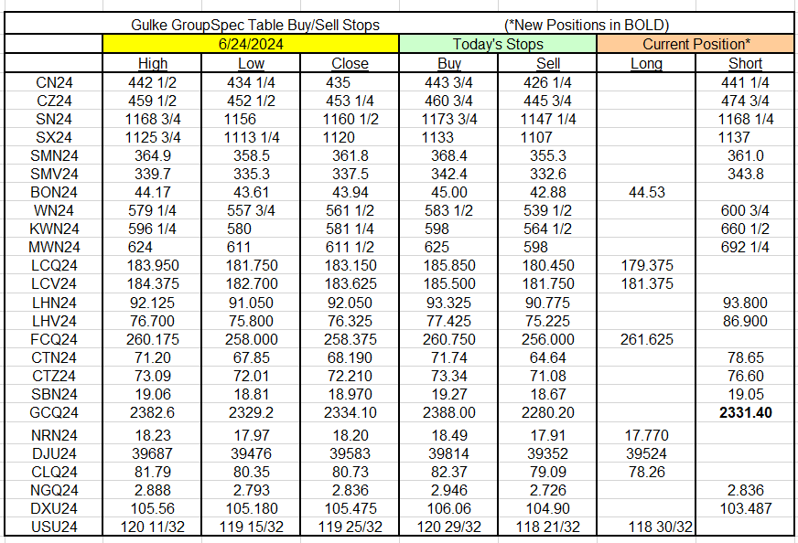

RESULTS HAVE MANY INHERENT LIMITATIONS, SOME OF WHICH RE DESCRIBED BELOW. NO REPRESENTATION IS BEING MADE THAT ANY ACCOUNT WILL OR IS LIKELY TO ACHIEVE PROFITS OR LOSSES SIMILAR TO THOSE SHOWN. IN FACT, THERE ARE FREQUENTLY SHARP DIFFERENCES BETWEEN HYPOTHETICAL PERFORMANCE RESULTS AND THE ACTUAL RESULTS SUBSEQUENTLY ACHIEVED BY ANY PARTICULAR TRADING PROGRAM. ONE OF THE LIMITATIONS OF HYPOTHETICAL PERFORMANCE RESULTS IS THAT THEY ARE GENERALLY PREPARED WITH THE BENEFIT OF HINDSIGHT. IN ADDITION, PROGRAM IN SPITE OF TRADING LOSSES ARE MATERIAL POINTS WHICH CAN ALSO ADVERSELY AFFECT ACTUAL TRADING RESULTS. THERE ARE NUMEROUS OTHER FACTORS RELATED TO THES IN GENERAL OR TO THE IMPLEMENTATION OF ANY SPECIFIC TRADING PROGRAM WHICH CANNOT BE FULLY ACCOUNTED FOR IN THE PREPARATION OF HYPOTHETICAL PERFORMANCE RESULTS AND ALL OF WHICH CAN ADVERSELY AFFECT ACTUAL TRADING RESULTS. THE GULKE GROUP HAS HAD LITTLE OR N\O EXPERIENCE IN TRADING ACTUAL ACCOUNTS FOR ITSELF OR FOR CUSTOMERS. BECAUSE THERE ARE NO ACTUAL TRADING RESULTS TO COMPARE TO THE HYPOTHETICAL PERFORMANCE RESULTS, CUSTOMERS SHOULD BE PARTICULARLY WARY OF PLACING UNDUE RELIANCE ON THESE HYPOTHETICAL PERFORMANCE RESULTS. This composite performance records are hypothetical and are used as a guide for position tracking purposes. Execution prices are an average execution price of the first ten trades recorded after advice has been posted and commonsense. In the event less than 10 trades are executed, prices will be determined by looking at fills, in relation to when the advice was given to clients, and a commonsense price will be determined. If no trades are executed, prices are determined by looking at a 1 min chart to determine the tracking price. The closing price on the previous day is used to determine the P/L listed in the Morning Comments and are net of average round turn commissions of $33.00 for futures and $36 for options and round turn fees of $5.34 for grains and $5.50 for livestock (these fees may change at any time by the CME). One of the limitations of a hypothetical composite performance records is that client decisions relating to the recipient’s advice may or may not elect to act upon such advice and timing of execution by clients of advice may create a difference in the execution price represented in the matrix below. Therefore, composite performance records may differ which may materially affect trading results.

