**June 25, 2024**

# ****Weather:****

More heavy rain expected in cornbelt and plains, this time about 200 miles further south than the last round- southern IA through Central IL/IN/OH, the drier areas. Major west coast heat wave on tap for the 4th.

·         U.S. Midwest is expecting timely rainfall over the next ten days supporting normal crop development

o   Relief from dryness is expected in the eastern and lower Midwest

·         U.S. Delta and southeastern states will also get a little rain in this coming week, but amounts will be lighter than usual offering only a temporary reprieve from dryness

·         U.S. temperatures will remain very warm across the southern Plains, in the Delta and southeastern states during the next ten days to two weeks.

·         Canada’s Prairies will get sufficient rainfall in the next two weeks to support longer term crop development, although the region will still be lacking degree day accumulations keeping plant growth rates slower than usual

·         Mexico’s monsoon will continue to develop with some moisture feeding into the southwestern United States in early July

·         Far western U.S. weather will be dry biased for the next ten days

·         West and South Texas rainfall I expected to be restricted for a while and temperatures in West Texas will be very warm

·         India’s monsoon will continue to advance northward benefitting many crop areas, although the daily rainfall may be lighter than usual except in a few north-central crop areas where it will be heavy

·         Southeastern portions of the North China Plain that has been dealing with dryness recently will get rain late this week and into the weekend; other areas in the region will remain dry and have an ongoing need for rain

·         Cool weather in central Russia crop areas will continue for a few days longer and then a notable warming trend is expected that will accelerate drying and induce some crop stress from eastern Ukraine into Russia’s southern Region

·         Australia winter crops will get timely rainfall

·         Europe will be wettest in central and interior western part of the  continent during the next week to ten days

·         Central America and southern Mexico rainfall will be abundant during the next ten days

# News:

* **USDA reported private sale of 209,931 metric tons of corn for delivery to Mexico. Of the total, 22,098 metric tons is for delivery during the 2023/2024 marketing year and 187,833 metric tons is for delivery during the 2024/2025 marketing year.**
* Traders reported Nonghyup bought a total of 135,000 mt of South American origin Corn. They also purchased 65,000 mt of optional origin feed Wheat at their tender today.
* **Dr. Cordonnier says there might be a half million to one million corn acres lost due to the excessively wet conditions and flooding in the northwestern Corn Belt.** Those acres will be counted as planted but reflected in a lower harvested acreage percentage, which he believes will be 90.3 to 90.7 this year, down from an average of 91.3. He says planting soybeans in late June or early July in the northwestern Corn Belt would be “a risky proposition,” as they would flower while the crop is in early development, “resulting in short-stature soybeans with a low yield potential.” **For now, Cordonnier left his corn and soybean production forecasts at 14.62 billion bu. and 4.46 billion bu., respectively.**
* **Forecasts for a more moderate La Niña in coming months is good news for Argentina’s crops, which will now likely receive more rain than previously expected, the Rosario Grains Exchange said. It noted, “This is good news for rainfall in Argentina during the (Southern Hemisphere’s) spring and summer period.”**
* Meteorologists suggest while an expected heatwave in Europe will likely have a negative impact on crops in the southeastern part of the continent, farmers in the west and northwestern regions will welcome the break from excessively wet weather.
* The production of corn-based ethanol in Brazil increased from 520 million liters in 2017/18 to 4.5 billion liters in 2022/23 according to the National Confederation of Industries (CNI). Corn based ethanol is expected to account for 19% of the ethanol consumed in Brazil in 2023/24, according to the National Corn Ethanol Union. Mato Grosso, which is the largest corn producing state in Brazil, is also the largest corn ethanol producing state with 70% of the total capacity. There are 18 corn ethanol facilities in Brazil with 16 located in the center-west region of Brazil. Eleven new corn ethanol facilities are in the planning stage with seven existing facilities undergoing expansion.

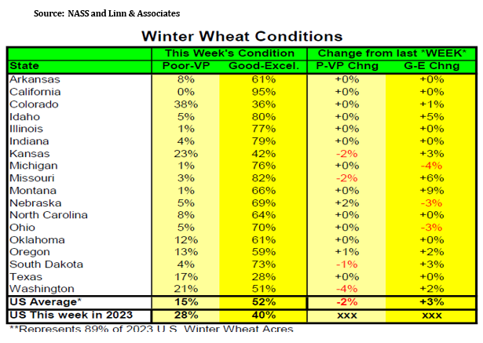

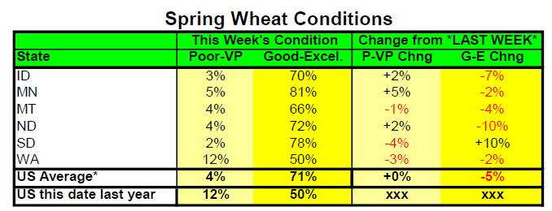

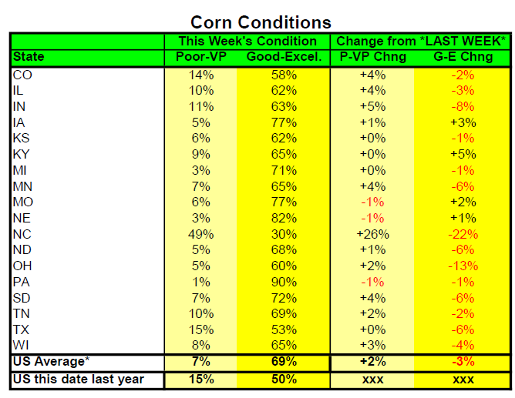

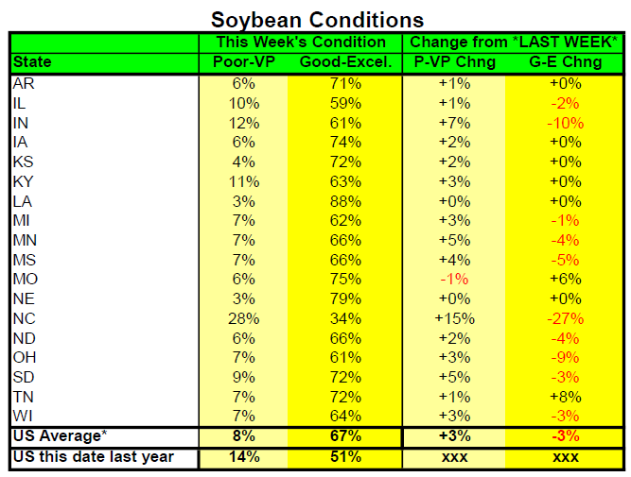

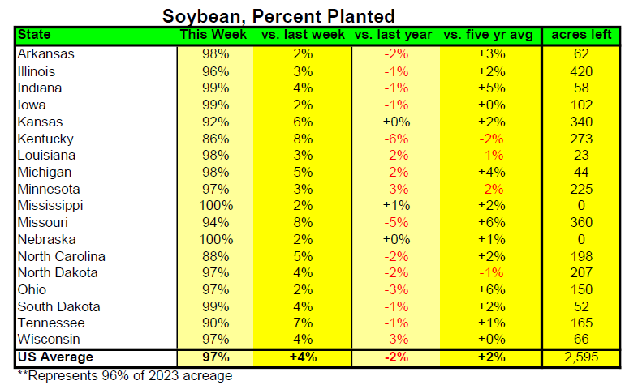

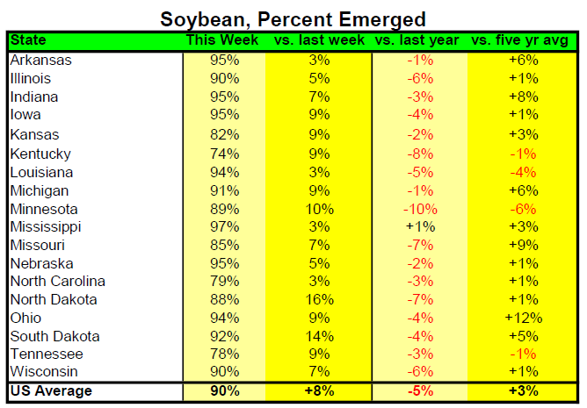

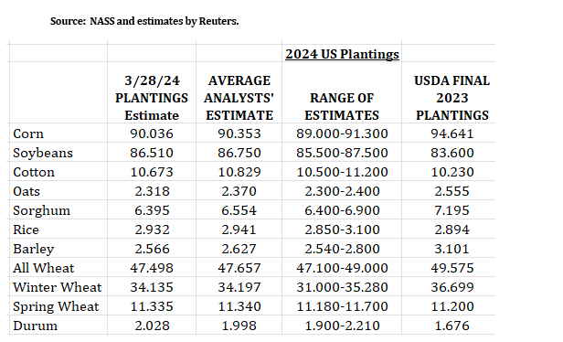

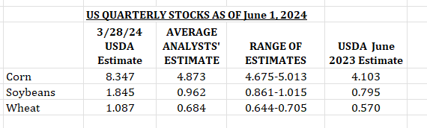

# Technically Speaking:

# Market Fundamentals:

November Soybeans had a daily key reversal higher but will need follow through to get our technical signals positive. If that happens it opens the door for a realistic move up to $11.55 or another leg higher at around the $11.70 range. The analyst guess for soybeans on Friday is looking for a reduction in soybean stocks and about a 250,000 acre increase in acres for new crop. Crop rating this week for soybeans showed a 3% increase over last week in the G/E ratings and a 2% increase in the P/VP category. IN (-10%) and OH (-9%) seemed to get hurt the worst followed by MS (-5%) and ND (-4%). IL was down 2% and IA held steady in the G/E category with an improvement in MO (+6%).

August Soymeal found some technical support at the 100-day simple moving average but was unable to close to new highs for the month of June, which is around $362 and closed near the 50-day simple moving average. Rumors of logistics may have helped the support in today’s action.

August Soyoil had a daily key reversal lower and needs to continue to find support near these June low levels otherwise a retest of this year’s lows of $42.83 is possible.

Canola had another daily key reversal lower in the November contract and is trading back down to the lows back in early March. Unless these levels can hold prices could leak down another $17 or so to get back near that $600 area.

Corn had a 12-cent range in the December contract and closed 3 ¼ from the highs but maybe more importantly it was 8 ¾ off the lows. Price did dip below the lows of $4.46 made back on Feb. 26 but rallied to close above those lows. Technically the picture still looks burdensome and another those lows are possible unless weather or a surprise in the USDA can spook the shorts or give the bulls a reason to step in. At these levels it may be viewed as a low-risk trade to enter the market here as there seems to be thoughts of a slight reduction in acres in the USDA report, weather does show some risk and farmers might be unwilling to let go of their old crop corn in a time when demand (ethanol, exports) seems to stay promising. Also, the crop ratings for corn dropped 3% in the G/E category and increased by 3% in the P/VP category. The states that had the rating drop the most were OH (-13%), IN (-8%), SD (-6%) and MN (-6%). If the market does start to show some strength look for a move back into the $4.60 to $4.75 range in the short term.

Chicago and Kansas City Wheat have given up basically all the gains since late April while Minneapolis Wheat continues to make new contract lows. Is wheat trying to steal away some demand from corn as feed?

Changes in weather outlooks and perceived crop damage moving forward is going to be a big part of price movement as a big increase in export demand this time of year seems unlikely. It may even be more important than Friday’s report which on the surface looks to be ho-hum. I feel that an increase in soybean acres will have more negative price action to soybeans than a decrease in acres will have a positive price action to corn.

**Yesterday’s Trades: no new trades.**

**ADVICE:  No New Advice. Some support levels were tested yielding opportunities to reduce coverage. A close over yesterday’s highs will make that support more important and impressive especially ahead of report; overnight action suggestion of another opportunity if market less concerned about the report and more on weather; a solid buy signal ahead of report would be impressive.**

**COMMENTS: Action yesterday had significance as it tested some important lows that had fundamental significance beginning with the Feb lows and onward including March 28 lows. How markets close after the report on Friday will be significant. Some re-positioning yesterday or just getting out ahead of the report may have caused the rally, as the trade was biased significantly negative ahead of report. Jamie has a complete fundamental detailed outlook on yesterday’s action.**

**WHAT OCCURRED YESTERDAY:**

* **C/S/W tested some key areas while at a oversold levels with the RSI in wheat at 13.**
* **Corn and soybeans rallied significantly off the early am lows yesterday.**
* **Nov beans SX posted a key reversal higher. SN is inverted to SX by nearly 50 cents.**
* **Overnight grains have retreated about 50% of their gains of yesterday keeping volatility and media types negative attitude in play while rains occurred over northern IL, WI, moving through Chicago on east/southeast.**
  + **The hard down overnight yesterday yielded an opportunity for profit taking by traders with another last night!!!!**
  + **Technically it was a positive price action yesterday—see charts above with comments—another rebound would be impressive**
* **The importance of the Friday report is key**
  + **Stocks will show if USDA/NASS are making any attempt to reconcile the March 28 report thought to be overstating corn stocks.**
  + **Planting intentions important as harvested acres likely lost in the flooding in four important states. Odds are those surveyed “intended” to plant all the acres. Hints of PP or failed acres visited but doubtful NASS will assume anything questionable.**
  + **Indirect implications of the S American crop without moving the needle much????**
  + **Certainly, anything that smacks of food inflation will likely be shunned.**
  + **S/D won’t be addressed but will be inferred by traders.**

**MEATS: The shortages predicted don’t seem to be happening but still in sight. Hogs got hit hard but LCV rallied smartly.**

**ECONOMICS: It will be interesting how Biden approaches the economy and how Trump reacts in the debate. The DJIA which was the lagger has gained some respect with the NASDAQ and S&P posting key reversals last week and the DOW reversed higher yesterday----the bloom may be off the Tech?**

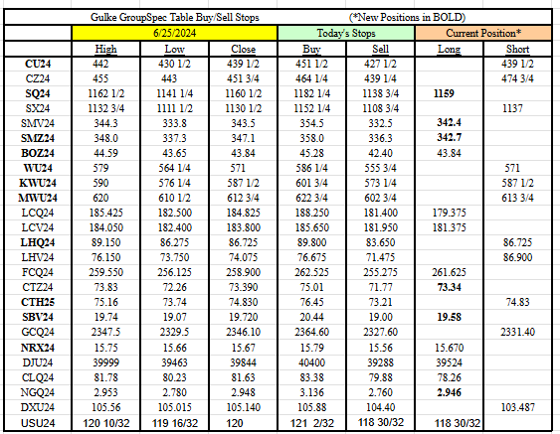

RESULTS HAVE MANY INHERENT LIMITATIONS, SOME OF WHICH RE DESCRIBED BELOW. NO REPRESENTATION IS BEING MADE THAT ANY ACCOUNT WILL OR IS LIKELY TO ACHIEVE PROFITS OR LOSSES SIMILAR TO THOSE SHOWN. IN FACT, THERE ARE FREQUENTLY SHARP DIFFERENCES BETWEEN HYPOTHETICAL PERFORMANCE RESULTS AND THE ACTUAL RESULTS SUBSEQUENTLY ACHIEVED BY ANY PARTICULAR TRADING PROGRAM. ONE OF THE LIMITATIONS OF HYPOTHETICAL PERFORMANCE RESULTS IS THAT THEY ARE GENERALLY PREPARED WITH THE BENEFIT OF HINDSIGHT. IN ADDITION, PROGRAM IN SPITE OF TRADING LOSSES ARE MATERIAL POINTS WHICH CAN ALSO ADVERSELY AFFECT ACTUAL TRADING RESULTS. THERE ARE NUMEROUS OTHER FACTORS RELATED TO THES IN GENERAL OR TO THE IMPLEMENTATION OF ANY SPECIFIC TRADING PROGRAM WHICH CANNOT BE FULLY ACCOUNTED FOR IN THE PREPARATION OF HYPOTHETICAL PERFORMANCE RESULTS AND ALL OF WHICH CAN ADVERSELY AFFECT ACTUAL TRADING RESULTS. THE GULKE GROUP HAS HAD LITTLE OR N\O EXPERIENCE IN TRADING ACTUAL ACCOUNTS FOR ITSELF OR FOR CUSTOMERS. BECAUSE THERE ARE NO ACTUAL TRADING RESULTS TO COMPARE TO THE HYPOTHETICAL PERFORMANCE RESULTS, CUSTOMERS SHOULD BE PARTICULARLY WARY OF PLACING UNDUE RELIANCE ON THESE HYPOTHETICAL PERFORMANCE RESULTS. This composite performance records are hypothetical and are used as a guide for position tracking purposes. Execution prices are an average execution price of the first ten trades recorded after advice has been posted and commonsense. In the event less than 10 trades are executed, prices will be determined by looking at fills, in relation to when the advice was given to clients, and a commonsense price will be determined. If no trades are executed, prices are determined by looking at a 1 min chart to determine the tracking price. The closing price on the previous day is used to determine the P/L listed in the Morning Comments and are net of average round turn commissions of $33.00 for futures and $36 for options and round turn fees of $5.34 for grains and $5.50 for livestock (these fees may change at any time by the CME). One of the limitations of a hypothetical composite performance records is that client decisions relating to the recipient’s advice may or may not elect to act upon such advice and timing of execution by clients of advice may create a difference in the execution price represented in the matrix below. Therefore, composite performance records may differ which may materially affect trading results.

