**July 17, 2024**

# ****Weather:****

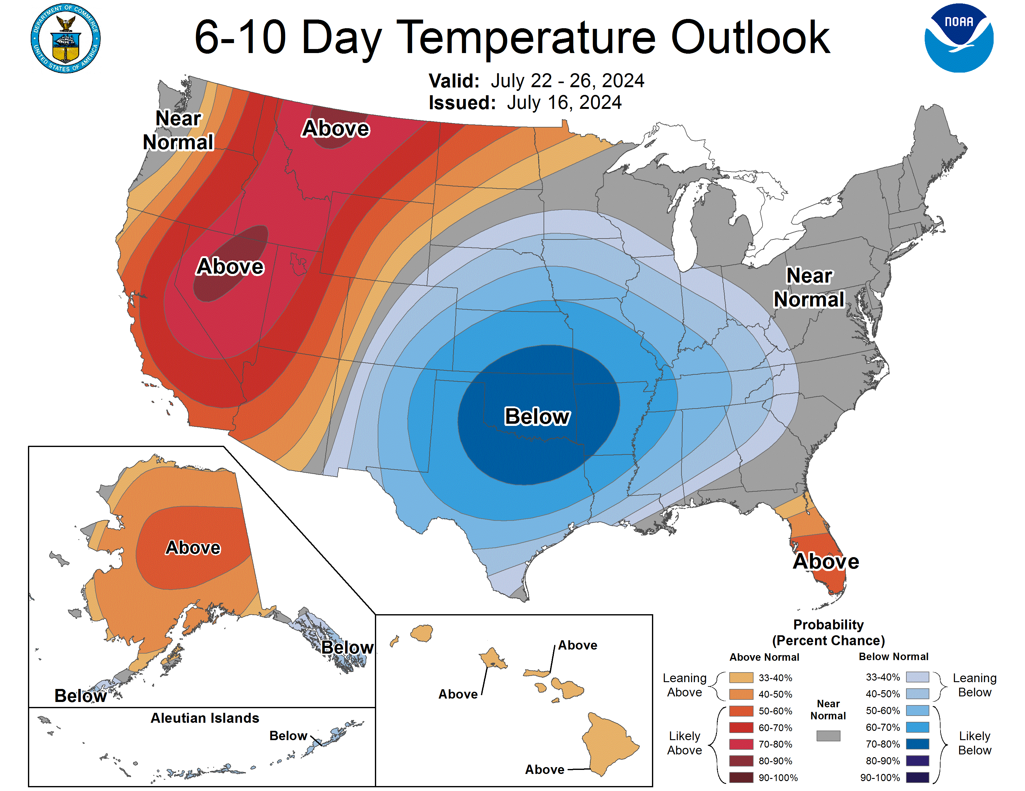

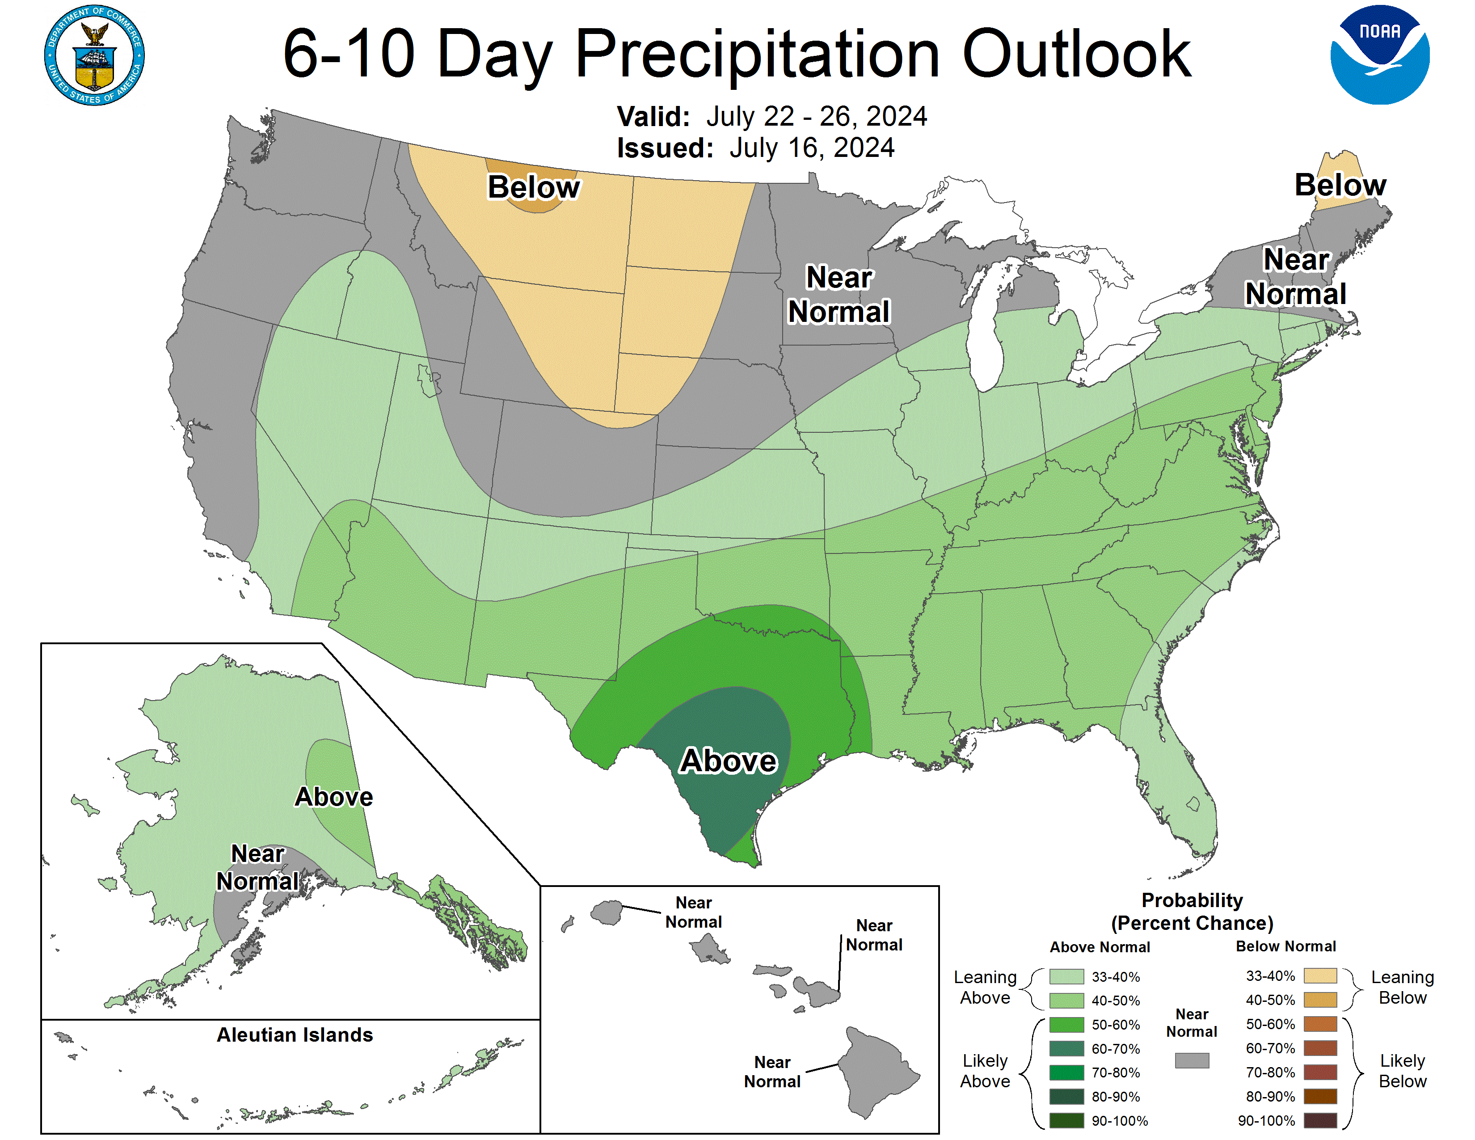

**WORLD WEATHER HIGHLIGHTS FOR JULY 17, 2024**

·         Scattered showers are advertised in southeastern Europe and areas to the northeast into Russia’s Southern Region and Kazakhstan next week

o   Some relief to recent warm and dry weather is expected, although much more rain will be needed

o   No further expansion of dryness to the north is expected after this weekend

·         Most of the North China Plain and Inner Mongolia that remain dry will get relief from dryness in the coming week to ten days

·         Flooding rain in east-central China should abate after Thursday of this week

o   Some crop damage has occurred, but a detailed assessment is not available

o   Drying will occur in east-central China this weekend into next week as a tropical cyclone evolves and moves to the East China Sea

·         Interior southeastern China will remain drier than usual for at least ten more days

·         India’s monsoon will be enhanced by a couple of low-pressure systems moving inland from the Bay of Bengal

o   Heavy rain is expected in the central parts of the nation in this coming week resulting in flooding and some threat to crops

**·         U.S. Midwest precipitation will be restricted over the next five days except near and west of the Missouri River valley where showers and thunderstorms are expected this weekend**

**·         U.S. Midwest rainfall will continue limited in the north during the 6- to 10-day period while southern parts of the region see periodic rain**

·         U.S. Delta and southeastern states along with eastern and southern Texas will be abundantly wet next week

·         West Texas weather will include some sporadic showers and seasonably cool weather in the coming ten days

·         Rain in the central and southern U.S. Plains will be great for summer crops and livestock

**·         Temperatures will remain very warm to hot in western parts of North America for the next ten days while the Great Plains and parts of the Midwest are cooler than usual**

**o   Temperatures in the Midwest and Plains will become more seasonable during the second week of the outlook**

·         Drying across Canada’s Prairies will threaten a reduction in grain and oilseed production especially in parts of southern and east-central Alberta and west-central through southern Saskatchewan

·         Argentina wheat and barley areas will get some beneficial rain Friday into next week; improved crop establishment is likely

·         Southern Brazil will finally start drying out over the next week to ten days

·         Central and northern Europe will see alternating periods of rain and sunshine during the next ten days

·         Australia winter crops are expected to continue getting some periodic light precipitation supporting good establishment

# News:

* Grain traders say Taiwan's MFIG reportedly paid $1.9765 cf over December CBOT 2024 corn futures for 65,000 mt of US origin feed corn.
* Egypt's GASC said they purchased a total of 770,000 mt of Wheat at their tender that closed Tuesday.  Some 720,000 mt was Russian origin with 50,000 mt was Bulgarian wheat. GASC's last wheat purchase was 470,000 mt of Russian, Romanian, and Ukraine origin grain, back on June 25th.
* US NOPA Soybean Crush Monday Recap: June 2024 US Soybean Crush: 175.599 million bushels; expected 177.94 mln bu.; prior month 183.625 mln bu; June 2024 US Soyoil Stocks: 1.622 billion lbs; expected 1.669 bln lbs; prior month 1.724 billion lbs.
* Dr. Cordonnier raised his corn yield estimate 1 bu. to 180 bu. per acre given beneficial weather as corn started pollination. That increased his corn production forecast to 14.85 billion bushels. Cordonnier left his soybean yield and production forecasts at 52 bu. per acre and 4.39 billion bu., respectively.
* India government data shows resurging July monsoon rains have prompted farmers there to ramp up planting of summer crops, including corn, cotton, and soybeans.  Monsoon rains in the first half of July was 9% higher than normal.  Farmers have planted around 14.0 mln ha of oilseeds, cotton on 9.6 mln ha, and corn on 5.88 mln ha.
* Ukraine’s summer crops may decline 20% to 30% in central, southern and eastern regions due to extreme heat, state weather forecasters said. The weather center said 30% to 50% of the overall area planted to summer crops could be affected by drought. Forecasters noted corn was at the most vulnerable stage of development to the effects of extreme temperatures and requires maximum moisture.
* Rapidly rising domestic phosphate prices have prompted Chinese ag group to urge export policy change unless companies halt their speculative buying and stabilize supplies to meet domestic demand.  Shipments of di-ammonium phosphate (DAP) over the Jan-May period have plunged 31%, while prices have risen by 10%; mono-ammonium phosphate (MAP) exports have dropped 30%, as prices have risen by 23.1% in the same time period.
* Despite efforts by the Biden administration to encourage US Midwestern farmers double cropping with winter wheat, global wheat prices at four-year lows have done little to nudge them to plant more acres.  After a small uptick in wheat acres in the 2022/23 season, acres have resumed their decades long downward trend.  Farmers say the crop insurance coverage offered for corn and soy planted after winter wheat did little to help farmers plant more acres.
* Russia's agricultural export inspection service Wednesday acknowledged it has shipped its first grain cargo from a new Baltic Sea export terminal own by Novotrans. The 12,000 mt grain cargo was destined for Cuba. Russia exports around 90% of their grain through its Black Sea terminals but is seeking to diversify their export routes with Baltic ports.
* Germany’s 2024 wheat crop will fall 6.2% from last year to 20.20 MMT, the country’s association of farm cooperatives said, down from its prior forecast of 20.34 MMT. Reductions had been expected following reduced planted areas and poor weather, including excessive rain this summer, it said.

# Technically Speaking:

# Market Fundamental

**Yesterday’s Trades: No New Trades**

**ADVICE: No New Advice:**Spec table largely short…   We advised selling calls last week which didn’t receive a lot of response probably because we didn’t add corn to the mix

Corn has rallied somewhat in a precarious situation----No new advice medium term except to say if you are a trader, selling a good rally 3-4-5 cents early may work but technically trying to turn up.  Terrible fundamentals in most everything expected so big wall of worry to climb.

THE CASH MARKET FOR CORN is wild to say the least.   Basis plus 40-60 in parts of WCB and in areas of good domestic demand.  Reports continue of end users having trouble buying corn.  Cattle feeders in Southwest US is paying $1.50 to $2 over.  Roger W reporting $5.50 in SW KS versus $3.72 cash in N IL.  The ethanol market in west IA is up to $.85 over.  For stocks report in Mar and June with huge on-farm storage, it doesn’t add up.  USDA/NASS reduced some of those phantom corn stocks in report last week raising usage and surprising traders but may be helping support futures but tough to overshadow weather and poor export demand.

We discussed the phantom stocks back in late March expecting the USDA to reflect potential errors in supply, but it will take months and not until perhaps Jan 12, 2025, to reconcile and election is over.  We were taken to task for mentioning this episode on DTN and will likely repeat it again if I can get internet and power back on!

It is difficult to believe but some areas may be deficient in nitrogen as yellowing is showing up and little incentive to side dress or use fungicide at these prices especially if yields down===all this does is help insurance payouts I hear.  So far rallies in corn futures are slow but steady.  If we find out that USDA lowers last year’s yield or “finds” more disappearance in the Sept 30 stocks report, it will have been a costly error in overstating corn stocks likely of a 20-30 cent too low of a low-end bar in price discovery.  The only item we have that will support new crop is a revision in old crop carryout of another 150-200 mil-bu and a yield below 180.  Traders don’t see that coming but black swan events usually are a surprise.  Both Biden and Trump see tariffs rising and now that China has a bigger/better relationship with S America, especially Brazil---Ag will suffer and domestic US demand can’t quickly make up the difference especially with the soy oil and corn being shunned by EPA.

Having said all that, we’ll continue to watch what brought us to the dance years ago for a hint of any changes. Right now, corn is being affected however small in the futures market —something needs to change long term. Drill baby drill doesn’t not suggest support for veggie fuels.

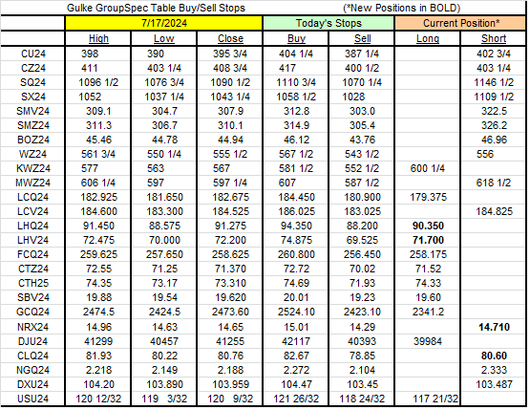

RESULTS HAVE MANY INHERENT LIMITATIONS, SOME OF WHICH RE DESCRIBED BELOW. NO REPRESENTATION IS BEING MADE THAT ANY ACCOUNT WILL OR IS LIKELY TO ACHIEVE PROFITS OR LOSSES SIMILAR TO THOSE SHOWN. IN FACT, THERE ARE FREQUENTLY SHARP DIFFERENCES BETWEEN HYPOTHETICAL PERFORMANCE RESULTS AND THE ACTUAL RESULTS SUBSEQUENTLY ACHIEVED BY ANY PARTICULAR TRADING PROGRAM. ONE OF THE LIMITATIONS OF HYPOTHETICAL PERFORMANCE RESULTS IS THAT THEY ARE GENERALLY PREPARED WITH THE BENEFIT OF HINDSIGHT. IN ADDITION, PROGRAM IN SPITE OF TRADING LOSSES ARE MATERIAL POINTS WHICH CAN ALSO ADVERSELY AFFECT ACTUAL TRADING RESULTS. THERE ARE NUMEROUS OTHER FACTORS RELATED TO THES IN GENERAL OR TO THE IMPLEMENTATION OF ANY SPECIFIC TRADING PROGRAM WHICH CANNOT BE FULLY ACCOUNTED FOR IN THE PREPARATION OF HYPOTHETICAL PERFORMANCE RESULTS AND ALL OF WHICH CAN ADVERSELY AFFECT ACTUAL TRADING RESULTS. THE GULKE GROUP HAS HAD LITTLE OR N\O EXPERIENCE IN TRADING ACTUAL ACCOUNTS FOR ITSELF OR FOR CUSTOMERS. BECAUSE THERE ARE NO ACTUAL TRADING RESULTS TO COMPARE TO THE HYPOTHETICAL PERFORMANCE RESULTS, CUSTOMERS SHOULD BE PARTICULARLY WARY OF PLACING UNDUE RELIANCE ON THESE HYPOTHETICAL PERFORMANCE RESULTS. This composite performance records are hypothetical and are used as a guide for position tracking purposes. Execution prices are an average execution price of the first ten trades recorded after advice has been posted and commonsense. In the event less than 10 trades are executed, prices will be determined by looking at fills, in relation to when the advice was given to clients, and a commonsense price will be determined. If no trades are executed, prices are determined by looking at a 1 min chart to determine the tracking price. The closing price on the previous day is used to determine the P/L listed in the Morning Comments and are net of average round turn commissions of $33.00 for futures and $36 for options and round turn fees of $5.34 for grains and $5.50 for livestock (these fees may change at any time by the CME). One of the limitations of a hypothetical composite performance records is that client decisions relating to the recipient’s advice may or may not elect to act upon such advice and timing of execution by clients of advice may create a difference in the execution price represented in the matrix below. Therefore, composite performance records may differ which may materially affect trading results.

