**September 20, 2024**

# ****Weather:****

**·         Argentina picked up some additional rain Buenos Aires and southern La Pampa Thursday improving topsoil moisture in a few areas**

·         **Argentina will experience some additional showers this weekend into early next week in the east and far north while west-central areas continue dry biased**

**·         Brazil rain will be greatest in the far south for another week**

**·         Center west crop areas of Brazil may see scattered showers develop in the last days of September and early October, although the resulting rain will be light**

o   Greater rainfall will be needed before planting can begin

o   **Southern Brazil first season corn planting will advance during the coming week and early soybean planting may occur later this month or in early October.**

·         Western Australia will continue drier than usual through the end of this month raising concern about future reproductive conditions; rain in October must improve

·         Interior east-central parts of China will remain drier than usual for an extended period of time

·         China’s winter wheat region in the North China Plain and Yellow River Basin should get rain late this month and in early October to support early planting

·         Russia’s Southern Region and eastern Ukraine will continue dry biased for the next two weeks

·         Russia’s Central Region, western Ukraine Belarus and western Russia will all receive some rain in the second week of the two week forecast while this first week is mostly dry

**·         U.S. eastern Midwest will get some beneficial rain next week easing long term dryness and briefly disrupting farming activity**

**·         Lower parts of the western U.S. Midwest and the central Plains will experience waves of rain this weekend into early next week slowing fieldwork, but improving soil moisture in wheat production areas for better planting, emergence and establishment conditions**

**·         Good drying conditions are likely in the northern U.S. plains, upper Midwest and Pacific Northwest**

·         Canada’s Prairies will see less rain after today so that better harvest conditions may evolve

·         A tropical cyclone is still predicted to evolve near or over the Yucatan Peninsula of Mexico during mid-week next week

o   This system may threaten the southeastern United States with heavy rain and strong wind speeds in the second weekend of the two week outlook

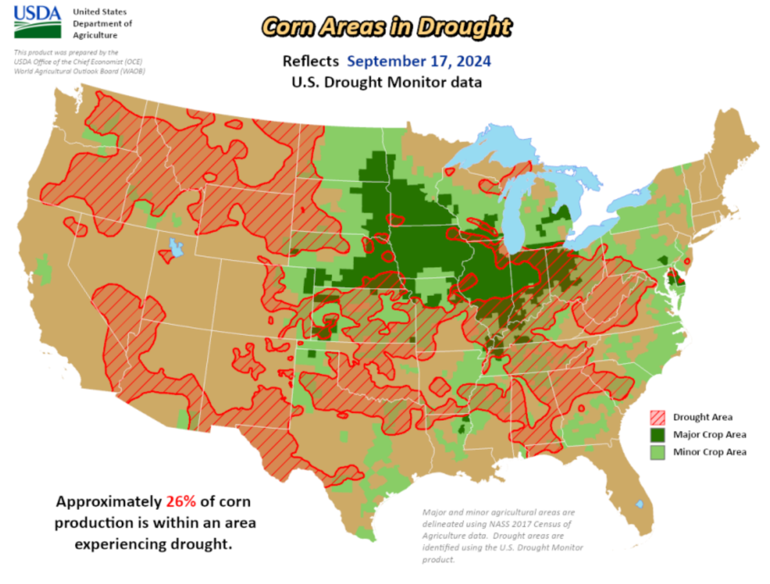

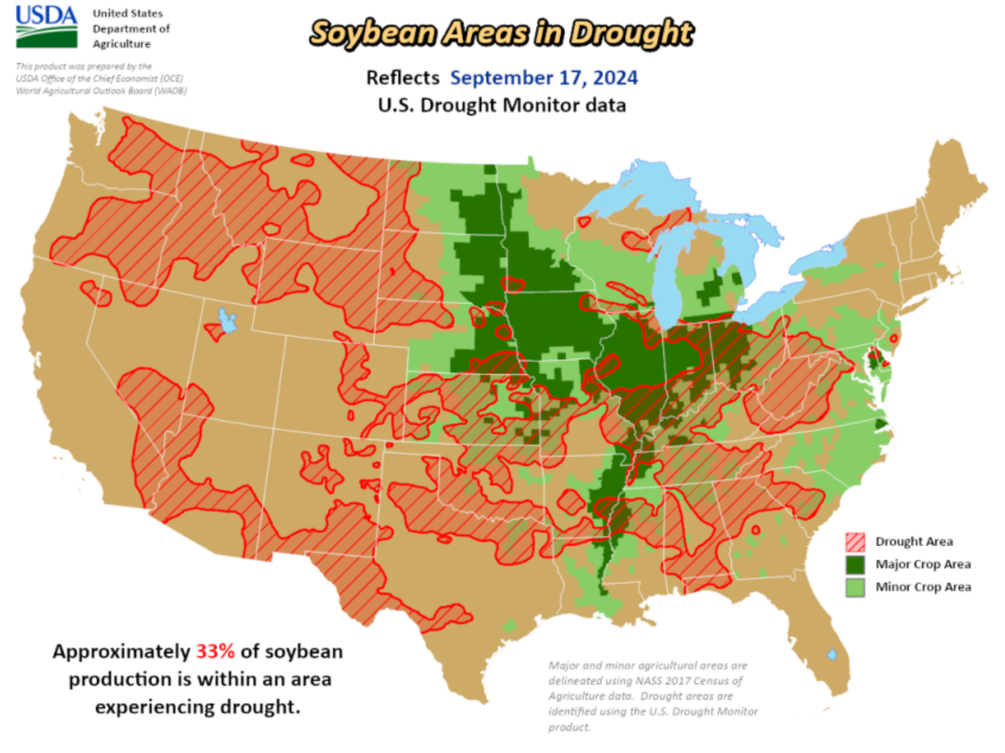

# News:

* **USDA reported private sale of 121,000 metric tons of soybeans for delivery to China during the 2024/2025 marketing year.**
* On Thursday, traders estimated commodity funds as net sellers 10,000 Chicago corn futures, and 3,000 Chicago wheat futures. Funds were said to be net sellers of 500 soy, but net buyers of 4,000 soyoil and 1,000 soymeal contracts.
* **Of the record 12.14 MMT of soybeans China imported in August, 10.24 MMT (84.3%) originated from Brazil.** U.S. soybeans accounted for 202,383 MT (1.7%) of China’s August imports. Through the first eight months of this year, China imported 53.8 MMT of soybeans from Brazil (up 217% from the same period last year) and 12.8 MMT from the U.S. (down 73%).
* **Coceral slashed its estimate for this year’s soft wheat production in the European Union and Britain to 126 MMT, down 8.5 MMT from its June forecast and 10% below year-ago.** It also lowered its outlook for 2024 barley production in the EU and Britain to 57.6 MMT from 59.9 MMT previously and cut its corn production forecast to 60.3 MMT from 64.8 MMT.
* **Ukraine’s ag ministry lowered its winter wheat seedings forecast by 210,000 hectares to 4.48 million hectares.** Record high temperatures and a lack of rain almost throughout the country in recent months have created unfavorable conditions for sowing winter crops.
* **Buenos Aires Grain Exchange weekly report suggested Argentina farmers in the north and west have begun abandoning some of their wheat fields due to drought conditions, and increased pest outbreaks. However, the exchange said eastern wheat growing regions are 80% good to excellent.**
* **Brazil Wheat Industry Association, Abitrigo, said the country's 250,000 mt additional wheat tariff free quota will mainly benefit Russian and US origin wheat**. This additional 250,000 mt runs through the end of 2024, adding to the annual 750,000 import free quota outside the Mercosur trade bloc. Argentina hasn't yet started harvesting their wheat crop.
* **Saudi Arabia's crude oil exports in July fell to their lowest level in nearly a year, data showed.** The country's oil exports stood at 5.741 million barrels per day in July, their lowest level since August 2023. Saudi Arabia is world's largest exporter of crude.

# Technically Speaking:

December corn is trying to stay in the upper range, but the technical indicators are wearing thin. It would be nice to see the 50-day MA hold otherwise prices may try to retest support at $3.90.

November Soybeans are trying to stay above the 50-day MA and closed yesterday at 10.13 ¼. MACD is in limbo with recent support at about 10.00.

# Market Fundamentals:

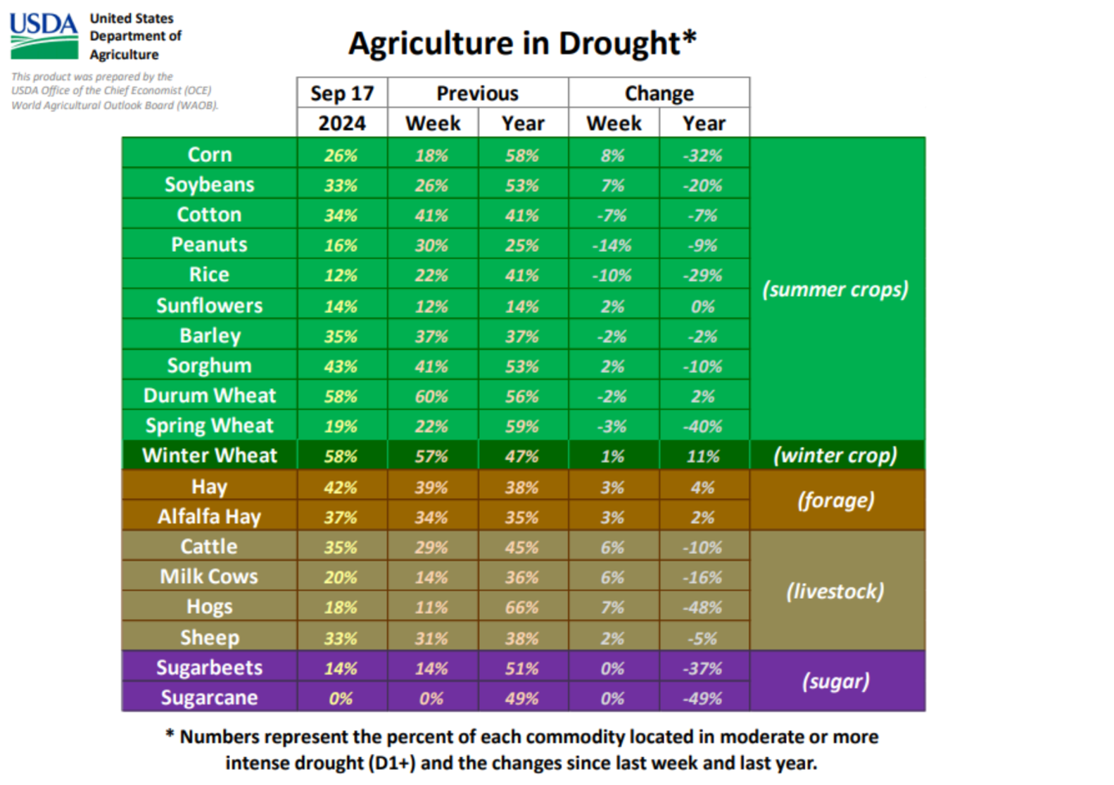

**Yesterday’s Trades: No new trades.**

**ADVICE:** No New Advice pending a midday update. We may have to do something with our long Oct. 4.05 corn puts as well as the long Oct. 10.00 soybean puts.

**COMMENTS:**

The weather in South America is slowly getting better for planting of first season corn and soybeans. Rain forecasted for the corn belt with some lower temps although it may be too late for some. Next week we are biased drier again.

The grains are pretty much red across the board except for wheat which had some supportive news worldwide as crop sizes are shrinking and calls for more imports could benefit US wheat. All classes are up anywhere from 4-7 cents.

Soybeans are down about 10 cents and are likely going to test support at $10 while corn is just a few cents lower on the day looking for support from the 50-day MA otherwise a move down to $3.90 looms and the MACD is in danger of going short.

Soymeal is already set up for a daily key reversal with lows at the 50-day MA while soyoil is lower on the day with possible resistance at its own 50-day MA.

One thing to note from a technical side is that after quite some time the 50-day MA is now in play for almost all the grains and is just another indicator out there that is used by traders. Just something of note as I have brough it up quite a bit this week.

The weekly charts are trying to turn positive for most of the grains and the meats but let’s see if some harvest pressure prevents them from turning long. Wheat looks the best of the bunch.

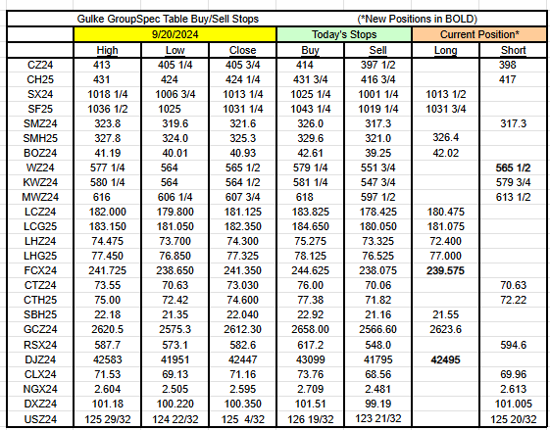

RESULTS HAVE MANY INHERENT LIMITATIONS, SOME OF WHICH RE DESCRIBED BELOW. NO REPRESENTATION IS BEING MADE THAT ANY ACCOUNT WILL OR IS LIKELY TO ACHIEVE PROFITS OR LOSSES SIMILAR TO THOSE SHOWN. IN FACT, THERE ARE FREQUENTLY SHARP DIFFERENCES BETWEEN HYPOTHETICAL PERFORMANCE RESULTS AND THE ACTUAL RESULTS SUBSEQUENTLY ACHIEVED BY ANY PARTICULAR TRADING PROGRAM. ONE OF THE LIMITATIONS OF HYPOTHETICAL PERFORMANCE RESULTS IS THAT THEY ARE GENERALLY PREPARED WITH THE BENEFIT OF HINDSIGHT. IN ADDITION, PROGRAM IN SPITE OF TRADING LOSSES ARE MATERIAL POINTS WHICH CAN ALSO ADVERSELY AFFECT ACTUAL TRADING RESULTS. THERE ARE NUMEROUS OTHER FACTORS RELATED TO THES IN GENERAL OR TO THE IMPLEMENTATION OF ANY SPECIFIC TRADING PROGRAM WHICH CANNOT BE FULLY ACCOUNTED FOR IN THE PREPARATION OF HYPOTHETICAL PERFORMANCE RESULTS AND ALL OF WHICH CAN ADVERSELY AFFECT ACTUAL TRADING RESULTS. THE GULKE GROUP HAS HAD LITTLE OR N\O EXPERIENCE IN TRADING ACTUAL ACCOUNTS FOR ITSELF OR FOR CUSTOMERS. BECAUSE THERE ARE NO ACTUAL TRADING RESULTS TO COMPARE TO THE HYPOTHETICAL PERFORMANCE RESULTS, CUSTOMERS SHOULD BE PARTICULARLY WARY OF PLACING UNDUE RELIANCE ON THESE HYPOTHETICAL PERFORMANCE RESULTS. This composite performance records are hypothetical and are used as a guide for position tracking purposes. Execution prices are an average execution price of the first ten trades recorded after advice has been posted and commonsense. In the event less than 10 trades are executed, prices will be determined by looking at fills, in relation to when the advice was given to clients, and a commonsense price will be determined. If no trades are executed, prices are determined by looking at a 1 min chart to determine the tracking price. The closing price on the previous day is used to determine the P/L listed in the Morning Comments and are net of average round turn commissions of $33.00 for futures and $36 for options and round turn fees of $5.34 for grains and $5.50 for livestock (these fees may change at any time by the CME). One of the limitations of a hypothetical composite performance records is that client decisions relating to the recipient’s advice may or may not elect to act upon such advice and timing of execution by clients of advice may create a difference in the execution price represented in the matrix below. Therefore, composite performance records may differ which may materially affect trading results.

